**User manual**

Introduction

Project Title: Court Case Handling System

Alternative Title: CCHS

Client: Registrar of Colombo District Courts

Colombo District Courts handles civil cases. The types of cases that come under civil cases can be divided into 3 broad categories.

* Money recovery and hire purchase cases are categorized under money related cases, divorce cases come under family problems and cases regarding the ownership of lands come under land cases.
* Out of all cases types, a large number of money related cases are examined. They are the most important type of cases, having a complicated procedure. Our client requested for a system which will assist the court staff with money related cases.
* Nowadays Colombo District Court faces a problem with a lot of money related cases pending to be heard. The delay in the court process has an effect on the country’s economics. With the increasing number of cases each year, court staff finds it difficult to handle cases. Therefore, we decided to develop CCHS, to handle money related cases of Colombo District Courts.

Purpose of the manual

This is useful for the court staff as a standalone system. This user manual guides them how to operate the system within them.

For The Register

User log-in

Explanation: - Existing user name and correct password will be entered

Input:-

User Name: 948190702V

Password : abc123

Output: - Displays main Interface of the user

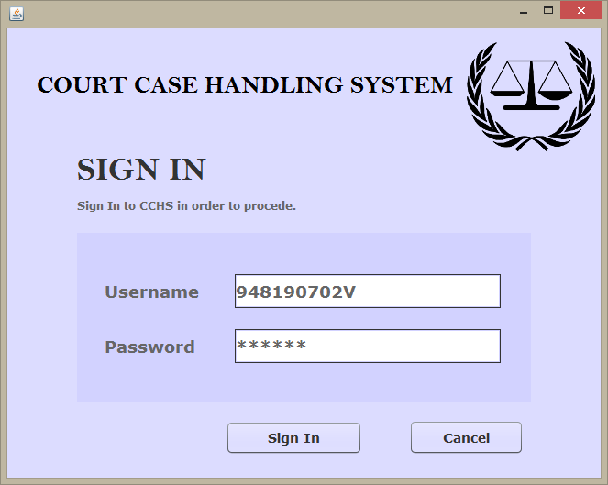

When you open the browser the first and the introductory interface is the sign in. you can sign into your professional site by typing the username (your employee no) and the password provided by the register at the appointment (you can change your password after the first log-in)

User registration

When an employee is newly appointed to the court, the register wants to do the user registration for that staff.

For this registration

* for the occupation click on the selection arrow and select the related occupation for the newly appointed staff
* In the user ID field enter the correct validated 5 digit user ID; this will be used by the employee to log-In his or her system.
* In the name field type the full name that wanted to use for other activities like salary particulars
* In the address field you can type the permanent or temporary address, this can be edited by the user
* for the date of birth select the correct date using the calendar
* enter the nationality and the contact number
* select the civil status as single or married, this field can edited by the user
* in the Email address enter a correct email ID with @ and the .com
* after filling this click ok

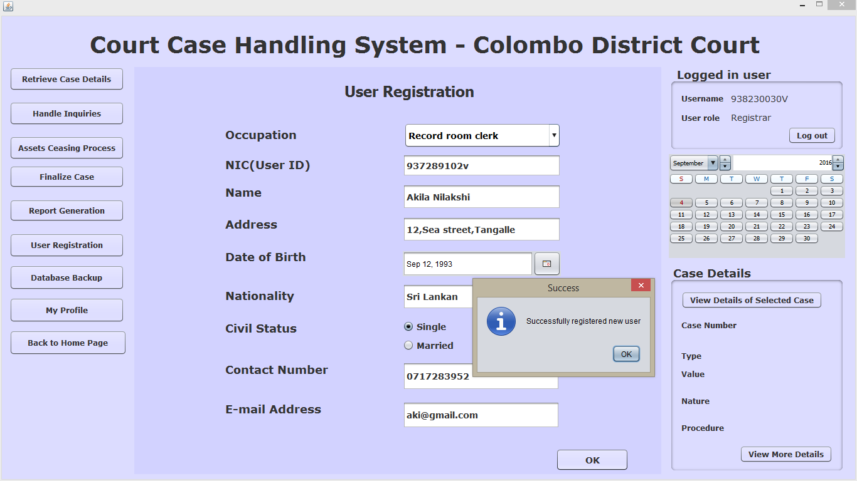

For the Record room clerk

User log-in

When you open the browser the first and the introductory interface is the sign in. you can sign into your professional site by typing the username (your employee no) and the password provided by the register at the appointment (you can change your password after the first log-in)

For log-in the same procedure are followed for all the staffs working in the court.

Explanation: - Existing user name and correct password will be entered

Input:-

User Name: 948190702V

Password : abc123

Output: - Displays main Interface of the user



Case registration

* case number:- select the corresponding case type from the list and click generate button, then the system will generate the case number automatically
* then click next
* case details:-
  + the type will automatically displayed
  + enter the value of the case correctly using “.00”
  + select the nature as “money case” or “money summary”
  + select the procedure as “regular” or “summary”
* then click next
* Plaintiff details: - enter the plaintiff ID, name, address then click “add to table” button. You can enter more than one plaintiff, and you can edit the details using the “clear text field”, “clear table”, and “clear selected rows” button.
* after enter these details click “next”
* Defendant details: - enter the defendant ID, name, address then click “add to table” button. You can enter more than one defendant, and you can edit the details using the “clear text field”, “clear table”, and “clear selected rows” button.
* after enter these details click “next”
* Lawyer details: - enter the lawyer ID, name, and address then click “add to table” button. You can enter only one lawyer at a time, if the plaintiff wanted to change the lawyer then only the lawyer’s details can be edited and you can edit the details using the “clear text field”, “clear table”, and “clear selected rows” button.
* then click next
* If any attachment like proxy or papers regarding the case, originals are collected in a file, and these documents are scanned and saved as an image file in the computer. For the attachments enter the name (what document) and click browse button and select the image file of the document. then click “add to table” button
* You can edit the details using the “clear text field”, “clear table”, and “clear selected rows” button.
* Then click save button to save the details to the data base.
* Then the Summary of the entered details are displayed, you can check if the details are correct or not, and you can update the database by clicking on the update button and save the details by clicking on the save button.

For the shroff

Stamp duty process

* first click on the relevant case number
* Then the all the values are automatically displayed in the relevant fields.
* then click the “view receipt details button” to view the receipt format
* then click “ print receipt”
* the receipt will be displayed
* click “print”
* then the receipt will be printed by the printer

For the subject clerk

Summon serving process

* first click on the relevant case number
* then select a future date as the first hearing date(this is done in behalf of the register)
* Number of copies will be calculate automatically by the system with the count of no of defendants
* then click “print”
* the summon that send to print will be displayed
* click ok to print summons

Handle fiscal report process

* from the fiscal report due list click the relevant case number
* select a option incase the fiscal handed over the summons or not
* if the fiscal handed over the summons, enter the date of handover in the “summon served date” field
* if fiscal not handed over the summons, enter a reason for the unavailability
* then click “save”

DS process

* the case number of the summons which are not handed over to the defendants will be displayed in the box
* click on the relevant case number and the reasons will be displayed automatically
* if you want to view the summon, click on the “view summon”
* no of copies to DS will be automatically displayed according to the number of defendants
* then click “print”
* the summon that send to print will be displayed
* click ok to print summons

Decree preparation

* from the list of cases which are given as the exparty judgment, select a case number
* judge and the decision will be displayed automatically
* no of copies will be displayed by the system according to the number of defendants
* then click “print”
* the decree which send to print will be display
* click ok to print the decree

Handle issued decree

* from the list of cases which has been given decree, click on the case number
* enter the date of issue
* then click “save” to save in the database

For the roll court clerk

Bench proceedings

* from the list of cases which are hear today, select the case number which is hear now
* select the judge’s name from the list
* select the option whether the “final judgment given” or” the next hearing date decided”
* if the next hearing date is decided, then select the next hearing date and enter the judge’s comments and click on the “confirm next hearing date”
* if the final judgment is given, enter the final decision and click “confirm final judgment”